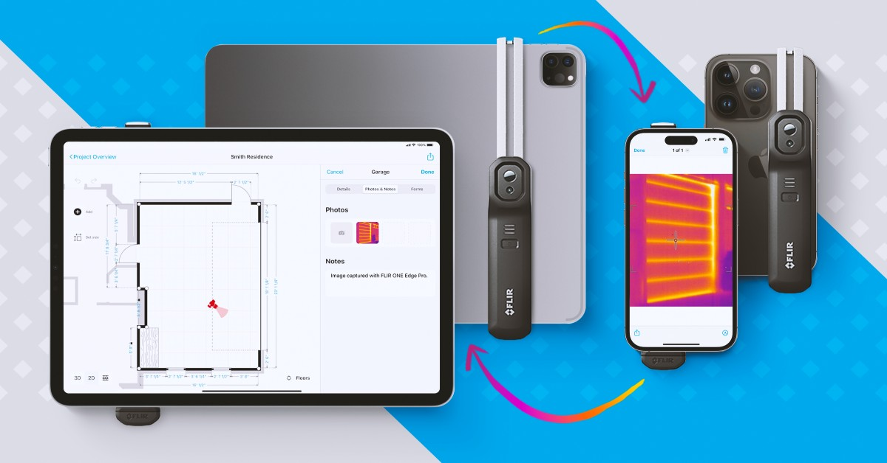

**Detect without damage: App for developers reveals the hidden cost of energy loss in seconds**

On-time and under-budget are two phrases which property developers know can never be taken for granted. Especially where renovations or restorations of older properties are concerned. Hidden structural issues, water damage, heat loss or ageing heating systems; they can all be significant (and expensive) problems which can set a build back by months.

The same goes for property surveys or insurance claims where potential property issues, if missed, can cause big problems later on.

Traditionally, detecting damage to properties has risked further disturbance of the fabric of the building with invasive tests conducted to assess the full extent of the issue. This can be costly, time-consuming and sometimes even makes existing problems worse.

magicplan changes all of that. Designed for remodeling, restoration, inspection, and claims professionals, this application makes invasive manual property inspections a thing of the past.

It’s been developed to make the job of creating floor plans easier, simplify reporting and generate cost estimates at the touch of a button.

And with recent updates adding further functionality, magicplan can now also show acute real-time energy loss and damage beneath the surface in real-time - revealing dangers that could otherwise be missed by visual inspection.

**Mobile thermography for the discerning developer**

By integrating FLIR’s industry-leading thermography, magicplan now allows developers to integrate essential energy loss and damage information into their reporting and planning. From pinpointing inefficiencies in insulation through to identifying water damage, magicplan works with the FLIR ONE Edge Pro to detect everything from extreme heat to pervasive cold spots - all of which can signify problematic damage.

The uses for this are limited only by the scope of the project it is put to work on. By combining the app’s extensive library of developer-led features with the FLIR ONE Edge Pro, it equips users with a professional-grade thermal camera that can detect heat of up to 400°C (752°F) with thermal sensitivity of 70 mK.

Now, those examining sites can detect more than meets the eye and elevate inspection with must-have data to help focus their plan, timeframe and estimated cost.

Whether it’s inspecting mechanical systems, investigating water loss, or checking ​​the output of an electrical panel, developers can deliver real-time insights without the need to bore, burrow or drill their way through physical obstacles.

**Planning around problem areas**

Developers know that until a thorough inspection has been carried out, every build can be subject to any number of vexing variables. magicplan allows users to do more than just passively relay data - it contextualizes it instantly and intuitively.

It allows users to create instant floor plans, both manually or by performing a quick scan of the room using their smartphone camera, as well as being compatible with laser meters with bluetooth technology for 100% accurate measurements. Creating projects in 2D and 3D and providing developers with a quote on the spot to supply to prospective clients, this latest collaboration with Teledyne FLIR means that everything from the most minute measurements to the most pervasive ‘unseen’ problems is displayed clearly.

**Pinpoint accuracy across every elevation**

Once a floorplan has been created using magicplan, users can choose to add their photos not just to an individual project, but can even decide its placement, classification and orientation.

Say, for example, a developer suspected a property suffering from water damage - whether through visual inspection or a room feeling colder than usual during a walkthrough. Using the FLIR ONE Edge Pro in conjunction with magicplan, they could easily perform a scan of the room and photograph areas that show anomalies - either on the surface or lurking beneath the surface.

Once detected, the concern can be added to a specific location on the floor plan so that anyone involved in the project can not only be aware of the issue, but also of its exact location and degree of severity.

Everything from a faulty thermostat impacting a heating system to invisible draughts from broken window seals through to rising damp and even the most minute fluctuations in insulation density, developers can now see beyond the visual spectrum and make real-time adjustments to their estimates with active thermography - all in the palm of their hands.

It’s ideally suited to every stage of development but is especially useful when it comes to inspection and claims prior to a buyer purchasing a property. With this potent combination of heat-sensitive hardware and insightful software, would-be purchasers could potentially save thousands by detecting unseen problems before they sign the dotted line.



Bernd Wolfram, Head of Product & Marketing at magicplan, said: “FLIR stands out as a technology provider that makes it easy to integrate its hardware with third party software applications like magicplan. “Integrated workflows are key to optimizing the daily workflows and productivity of field technicians!”

<https://www.flir.com/discover/professional-tools/developers-reveal-hidden-energy-loss/>